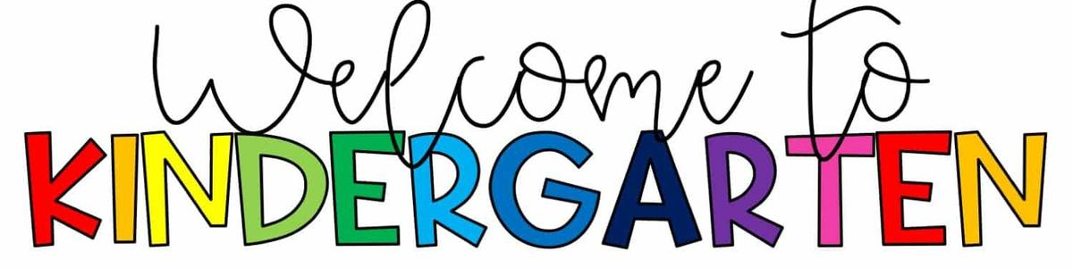

Riverbend Elementary Supply List
2022-2023
- Backpack* (see note below)
- Kindergarten Mat
- Small Blanket or Towel
- Crayons- 24 pack
- Colored pencils- 24 pack
- White glue sticks- 4 sticks
- One 3-pronged folder with pockets
- Headphones (no earbuds please)
- $5 Student Consumables Fee

*As we strive to maintain a safe learning environment, rolling backpacks are not permitted.
Donation items appreciated: Tissues, Ziploc bags (any size)
Supply lists are a result of parent requests year after year. We want our families to know, however, that we will provide each and every Riverbend student everything they need. We thank our community for their support, generosity, and their love to start each new academic year excited about our school!

